CREATE A FORM

**IBM-PROJECT-18767-165968727**

DATE:04-11-2022

TEAM ID: PNT2022TMID10261

PNPNT2022TMID04003T2022TMID42603

Connecting nodes using node-red:

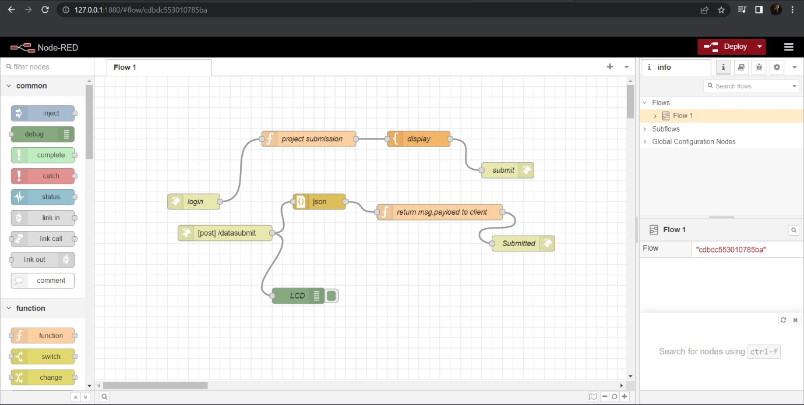

After deploying the nodes:

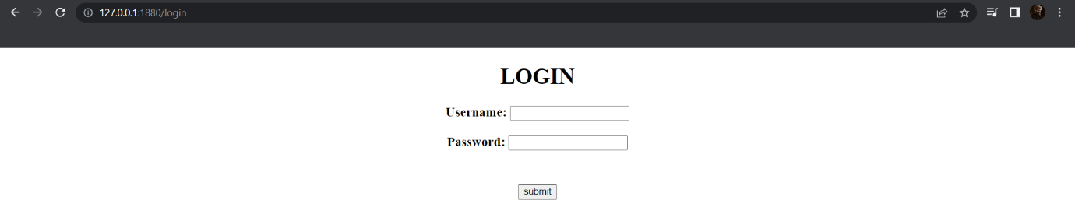

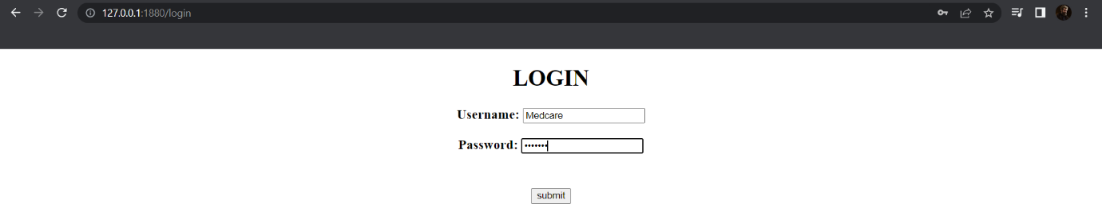

After clicking on Submit button:

